TES-070 Custom Interface Unit Test Results
State of New Hampshire
SoNH_INT_FIN_013 GL Transaction Interface
Document Properties
Author | Ivy Cafe
Creation Date | 09/08/2025
Last Updated | 09/08/2025
Document Reference | ANA-050+DES-020__INT_FIN_GLTransactionInterface_v1.0.docx
Version | 1.0

Approvals | Position

Document Control

Change Record
1
Date | Author | Version | Change Reference
09/08/2025 | Ivy Café | 1.0 | Creation / Initial Draft

Reviewers
Name | Position

Contents
1 Document Control 2
1.1 Change Record 2
1.2 Reviewers 2
2 Custom Interface Unit Test Summary Results 4
2.1 Unit Test Summary 4
2.2 Test Scenarios 4
3 Custom Interface Unit Test Detailed Results 5
3.1 Scenario: Successful import and interface Of GL Transactions 6
3.2 Scenario: Error upon DB Import to GL Transaction Interface (Staging) 8
3.3 Scenario: Successful import with Interface error. 10

Custom Interface Unit Test Summary Results
The Custom Interface Unit Test Results consolidate the findings from the specifications written in SONH_ANA-050+DES-020_GL Transaction Interface. In this section, the summary results are presented for the overall Custom Interface Unit Test.

Unit Test Summary
The following results summarize the counts and percentages for Unit Test:
Count of Total Tests | Count of Completed Tests | % of Completed Tests | Count of Passed Tests | Count of Failed Tests | % of Passed Tests
3 | 3 | 100% | 3 | 0 | 100%

Test Scenarios
Scenario # | Test Scenario | Infor Test Result | SONH Test Result | SONH Tester
3.1 | Successful Import and Interface of GL Transactions | PASS
3.2 | Error upon DB Import to GL Transaction Interface (Staging) | PASS
3.3 | Successful Import and with Interface Errors | PASS

Custom Interface Unit Test Detailed Results
The Custom Interface Unit Test Detailed Results provide the results for each individual test case.
Tenant: https://mingle-portal.inforcloudsuite.com/v2/NMR2N66J9P445R7P_AX4

Prerequisites for testing:
    - Users must have the roles of Process Server Administrator and Staff Accountant role.
Note: the email notification includes “Link to Interface Result” which would require at least Financials Processor role to open the link correctly.
    - Assigned user per Agency must have access to Infor SFTP.
    - User must place the inbound file to the designated SFTP folder: /Infor_FSM/GLTransactionInterface/Inbound
    - Inbound interface file must follow the provided Infor Mapping File format for GL Transaction Interface.
    - Inbound interface file must follow the provided naming convention per file:
GLTRANSREL.<AgencyNumber><AcronymofSubsystem>.YYYYMMDDHHMM.csv

Notes:
      - multiple Run Groups under one file name are not allowed for security administration purposes.
      - Run Groups must be similar to the filename
      - YYYYMMDDHHMM = Year, month, date, hour and minute of upload

    - Email configuration setup for recipients.
Navigation Path: Process Server Administrator Role > Configuration > System Configuration > FSM > Search Property Name:
      - FSM_FIN_GLTransactionInterface_INT_013_EmailTo
      - FSM_FIN_GLTransactionInterface_INT_013_ErrorEmailTo
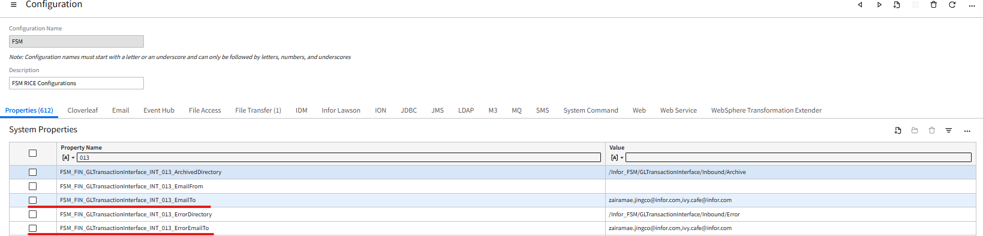
    - Multiple emails can be assigned, with comma “,” as a separator.
    - This configuration is expected to receive notifications for the following:
      - FSM_FIN_ GLTransactionInterface_INT_013_EmailTo
- for Successful Import and Successful Interface, and Interface Error
      - FSM_FIN_ GLTransactionInterface_INT_013_ErrorEmailTo
- for Import Error and Interface Error

Note: comma “,” should be used as a separator in adding multiple emails
(i.e angeli.pineda@infor.com,joshua.adato@infor.com)

Scenario: Successful import and interface Of GL Transactions

Description
Agency creates GL Transaction inbound files based in FSM format with populated information related to GL Transactions for the day or week and drop these files to Infor SFTP.

Test Steps
No. | Steps | Result
1 | - Log into FTP Program using the Infor SFTP credentials  - Navigate to this Folder directory:  /Infor_FSM/GLTransactionInterface/Inbound  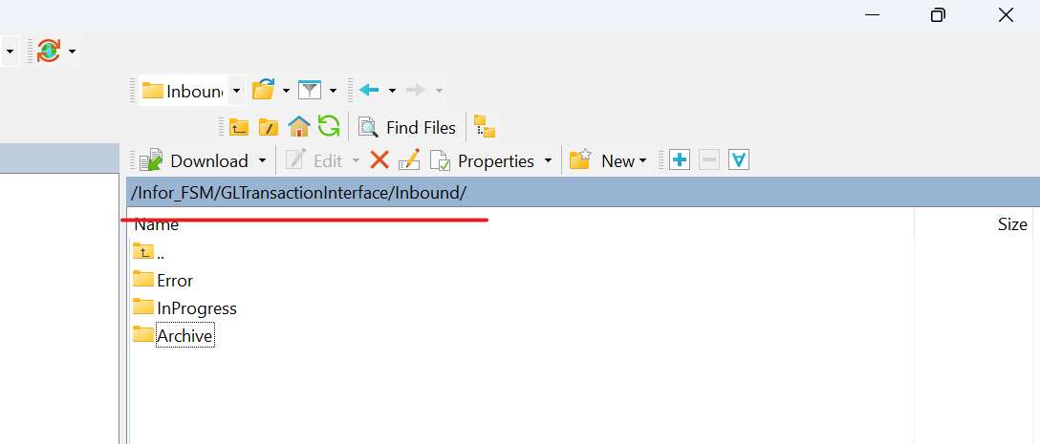  - Drop the GL Transaction inbound file in the directory.  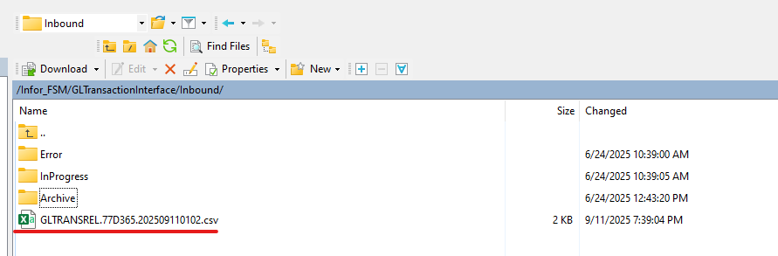  - Wait for file channel to trigger scanning (currently scheduled every 5 mins)  - For manual trigger for the file scanning, refer to Step 2 | PASS
2 | - Log into Infor FSM as Process Server Administrator > Administration > Channels Administrator > File Channels tab > Search for SONH_GLTransactionInterface in the Channel Name.  - Right click and click Scan Now.  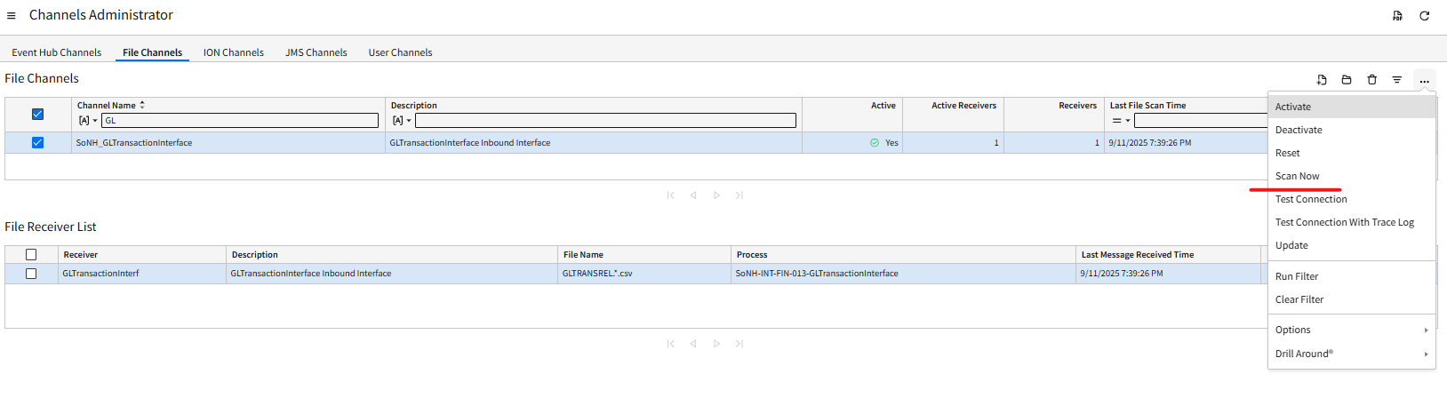  - Last Message Received Time of the GLTransactionInterface under the File Receiver List would be updated to the current date and run time.  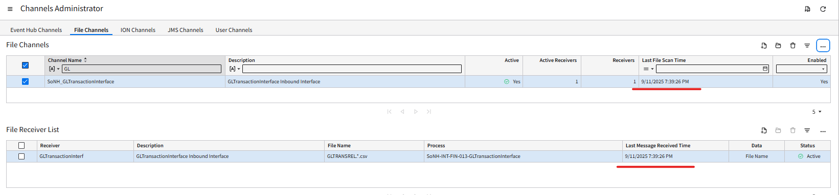  - Files would be consumed when the FTP Program folder is refreshed.  - File are imported to GLTransactionInterface staging business class  - Automatic interfacing of imported data to FSM via IPA | PASS
3 | - Email notification is sent to user for Successful Load of data. Click on the email link to view the results. The email notification also includes the number of records (Journal Lines) successfully interfaced.  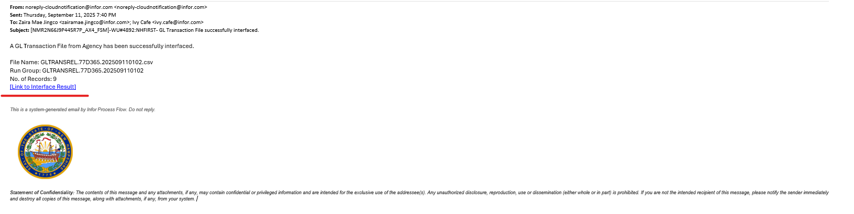  - Double-click the Link to Interface Result in the email notification.  Note: as mentioned in the Pre-Requisites section, accessing the ‘Link to the Interface Result” in the email would require users to have “Financials Processor” role  - Double-click RunGroup to open the record.  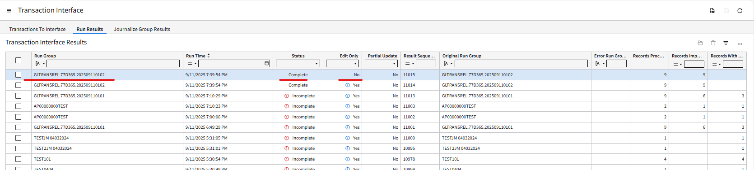  - The Journals created will be available  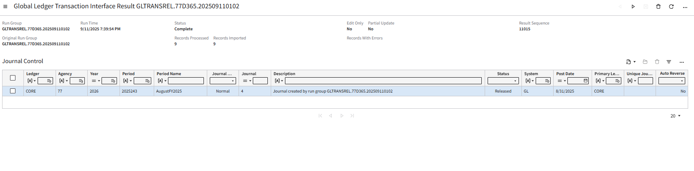  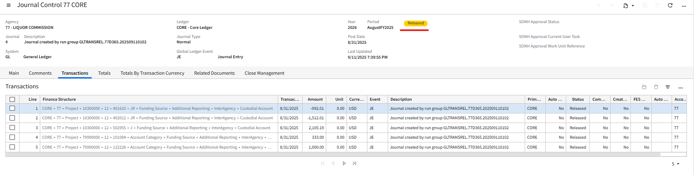 | PASS
4 | - The work unit generated can also be checked to ensure that the IPA process ran smoothly without errors. This is where the Process Server Administrator should go should there be any errors encountered in the processing.  Navigation Path: Process Server Administrator role > Administration > Work Units > Work Units > check the Work Unit status - “Completed”. | PASS

Results
- Files placed in SFTP folder with the correct file naming conventions are consumed by IPA.
- A work unit is created for the processing of the files.
- Files are imported to GLTransactionInterface staging business class.
- IPA automatically interfaces the imported data in FSM.
- Journal Control is successfully created in FSM.
    - Email notification is sent to users for Successful Load of data.

Scenario: Error upon DB Import to GL Transaction Interface (Staging)

Description

When a user submits an inbound interface file to FSM with DB import issues - IPA will process the GL Transaction interface files, validate the data, and return any detected errors.
- The interface files may encounter DB Import issues due to, but not limited to, the following reasons:
  - Incorrect data format (i.e date formatting – YYYYMMDD, etc)
  - Misspelled headers or improper header formatting; column headers do not match FSM fields.
Note: the interface files with incorrect file naming convention will not be processed by FTP.

Test Steps
No. | Steps | Result
1 | - Log into FTP Program using the Infor SFTP credentials  - Navigate to this Folder directory:  /Infor_FSM/GLTransactionInterface/Inbound    - Drop the GL Transaction inbound file in the directory.  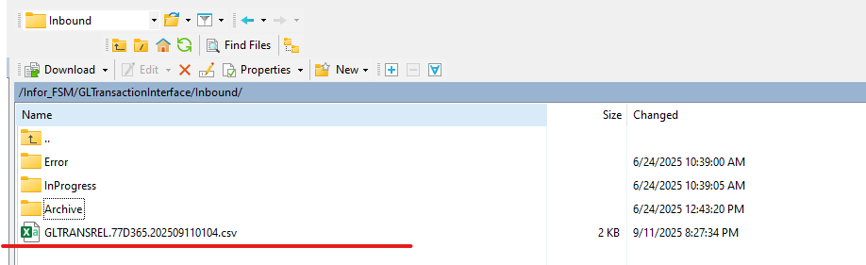  - Wait for file channel to trigger scanning (currently scheduled every 5 mins)  - For manual trigger for the file scanning, refer to Step 2 | PASS
2 | - Log into Infor FSM as Process Server Administrator > Administration > Channels Administrator > File Channels tab > Search for SONH_GLTransactionInterface in the Channel Name.  - Right click and click Scan Now.    - Last Message Received Time of the GLTransactionInterface under the File Receiver List would be updated to the current date and run time.  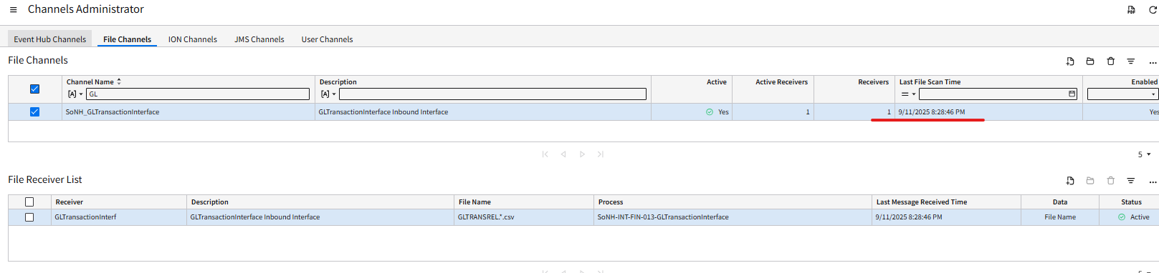  - Files would be consumed when the FTP Program folder is refreshed. | PASS
3 | - Records with error are not imported to the GLTransactionInterface staging business class dur to DBImport errors. Thus, records will not be moved to the next process and be interfaced.  - An email notification will be sent with DB import error attached.  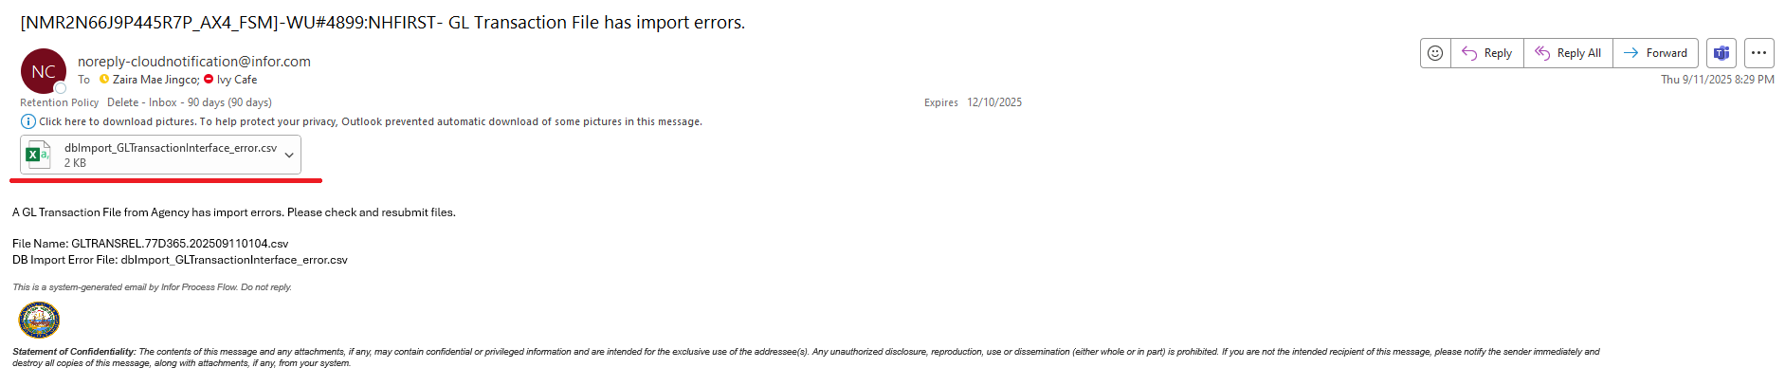 | PASS
4 | - Open attached error files to view errors. Below are sample errors in the report file:  - Invalid Data format for date – should be YYYYMMDD  - Bad Number Format for Amount – should be no comma.  - Violation of Primary Key – two lines sharing the same Sequence Number. Should be unique per line.  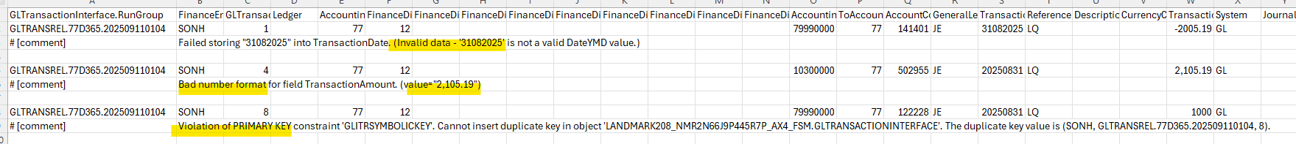 | PASS
5 | - The work unit generated can also be checked to ensure that the IPA process ran smoothly without errors. This is where the Process Server Administrator should go should there be any errors encountered in the processing.  Navigation Path: Process Server Administrator role > Administration > Work Units > Work Units > check the Work Unit status - “Completed” with error.  - User to correct the interface file based on the error and repeat the process (Step 1) | PASS

Results
- Files are not imported to GL Transaction Interface staging business class due to DBImport errors.
- An email notification will be sent with the DB import error attached.

Scenario: Successful import with Interface error.

Description
- For instances when run group resulted in some GL Transaction Lines that encountered interface errors.
- Interface files which include records that will encounter interface errors due to, but not limited to, the following reasons:
  - Records interfacing dated in closed periods.
  - Other setups or configurations that do not exist or do not match with the other data values (i.e Account Code, Accounting Unit, Fund)

Test Steps
No. | Steps | Result
1 | - Log into FTP Program using the Infor SFTP credentials  - Navigate to this Folder directory:  /Infor_FSM/GLTransactionInterface/Inbound    - Drop the GL Transaction inbound file in the directory.  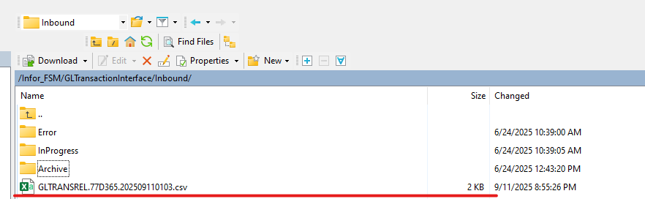  - Wait for file channel to trigger scanning (currently scheduled every 5 mins)  - For manual trigger for the file scanning, refer to Step 2 | PASS
2 | - Log into Infor FSM as Process Server Administrator > Administration > Channels Administrator > File Channels tab > Search for SONH_GLTransactionInterface in the Channel Name.  - Right click and click Scan Now.    - Last Message Received Time of the GLTransactionInterface under the File Receiver List would be updated to the current date and run time.  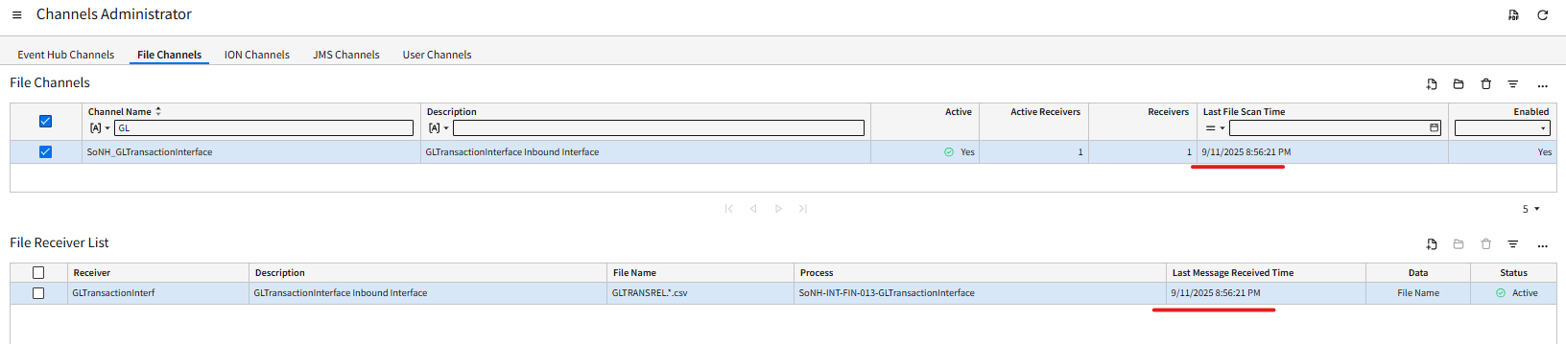  - Files would be consumed when the FTP Program folder is refreshed.  - File are imported to GLTransactionInterface staging business class  - Automatic interfacing of imported data to FSM via IPA | PASS
3 | - Email notification would be sent containing the number of records that encountered an error.  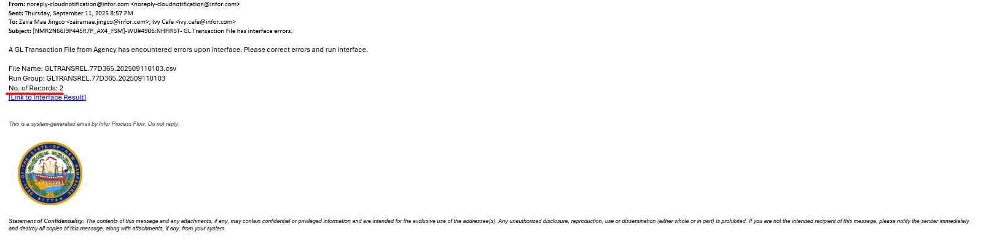  - Double-click the Link to Interface Result in the email notification.  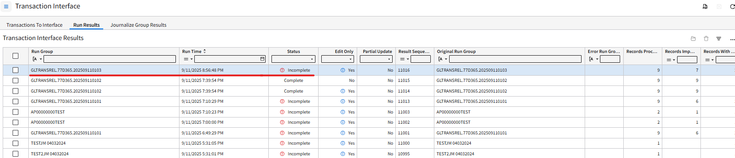  Note: as mentioned in the Pre-Requisites section, accessing the ‘Link to the Interface Result” in the email would require users to have “Financials Processor” role | PASS
4 | - Double-click Run Group (Status Incomplete) to open the record.  - On the Uninterfaced Transactions tab – specific errors are identified.  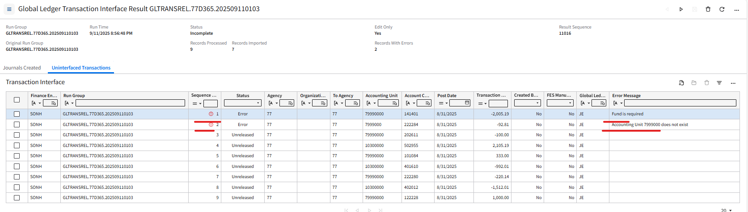  - Open the records and perform necessary corrections. Once done, errors are removed.  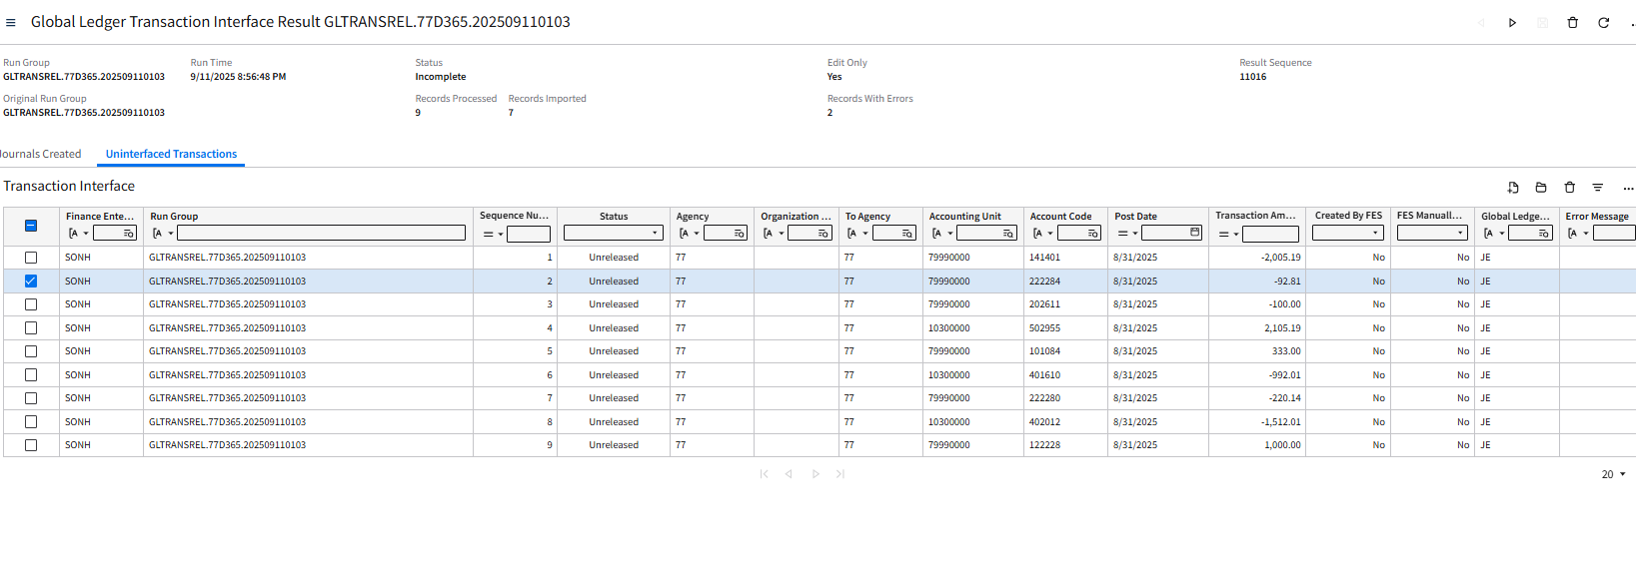  - Select All Actions and select Front End Split Transactions.  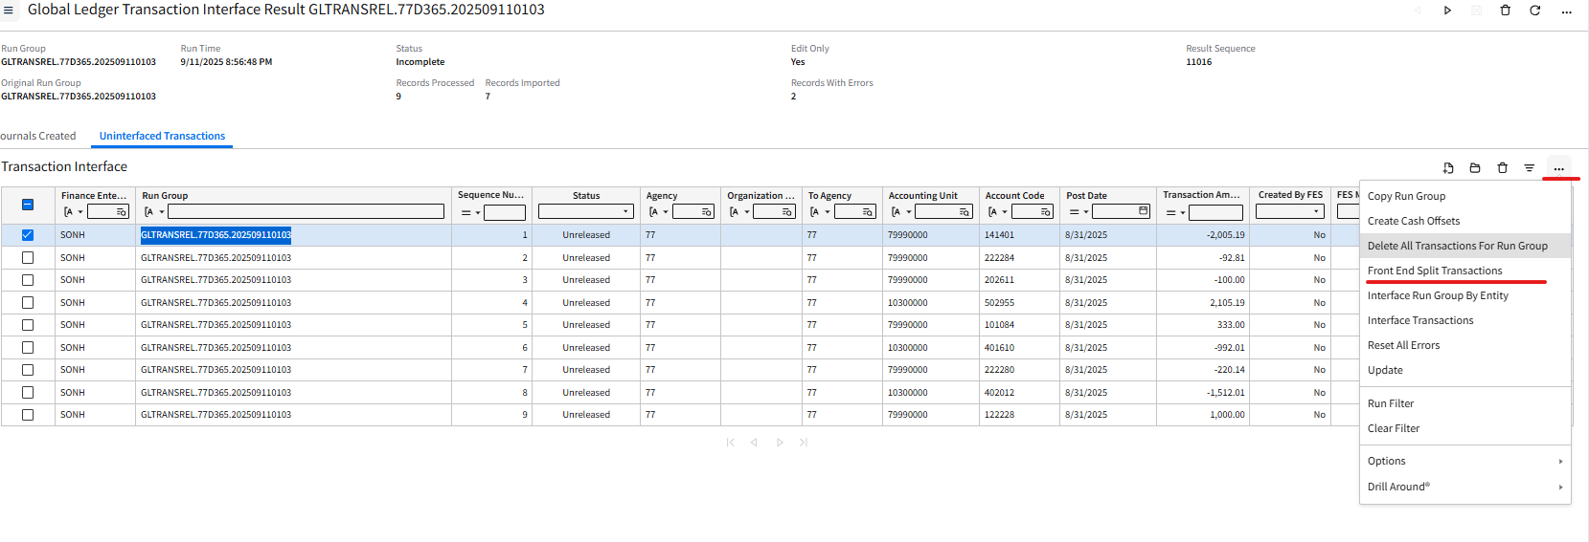  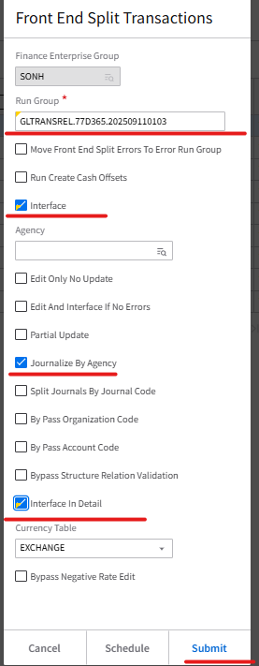  - User has the option not to process Interface after correcting the records. The GL Transaction Interface Job (EXT_FIN_070) will be able to process this Run Group.
5 | - Go back to the Interface Result – Run Group will be Complete  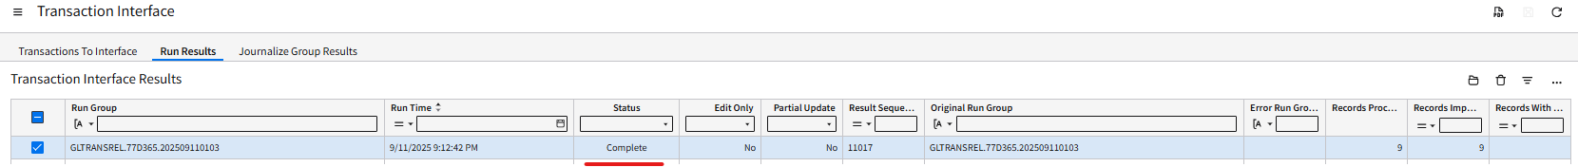  - Journal record is created  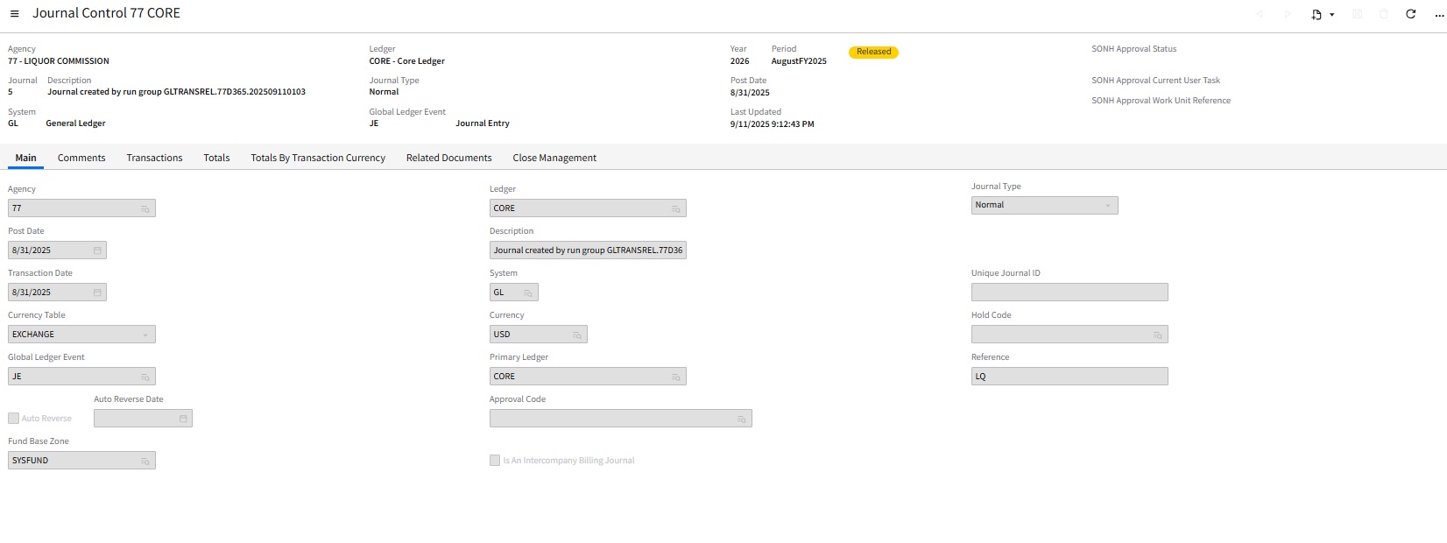 | PASS

Results
- Email notification was sent containing the number of records in error.
- User will was able to reprocess the records with error after the necessary updates are made.

